# Chapter 4. Implementation

## Unity Project Development

Sprint 2: 27th January – 10th February

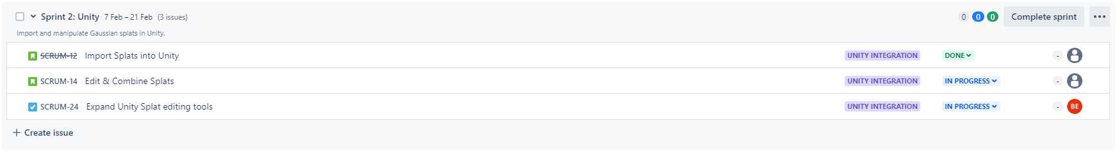

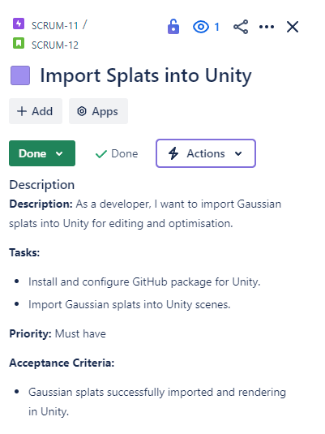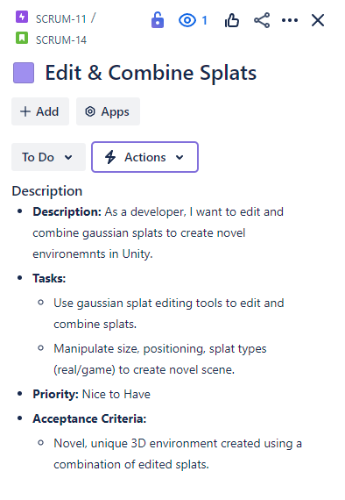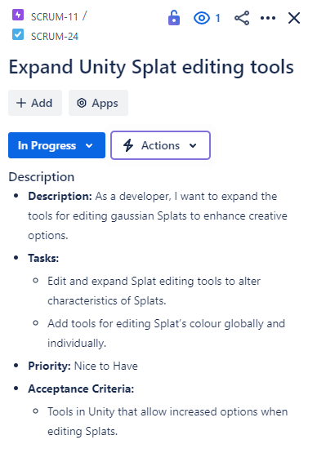

Currently, this [Github Repo](https://github.com/aras-p/UnityGaussianSplatting) project (Pranckevičius, 2024) is suitable for allowing the importing and exporting of Gaussian Splats in Unity (Figure 1), as well as allowing certain alterations to be made. However, there is a lack of tools for editing Splat attributes individually.

This sprint aims to edit this Unity project's code to allow the editing of individual Splat parameters such as colour, dimension, shape and alpha, globally and individually to address the current lack of tools for adjusting individual Splat attributes in this Unity project. These tool additions could expand the creative potential of this workflow, such as changing daytime scenes to night with global colour shifting and editing the colour of clothes or objects by individually selecting Splats.

It is worth noting that global colour changes can also be done by colour-correcting footage before the training and creating of the Splat. However, this process is far less flexible as once the Splat is trained, and imported into a scene, it will still be stuck with the the same colour attributes it was trained with.

(Could be worth researching the possibility of altering footage colour for improved Gaussian Splatting creation, such as boosting contrast to improve key point tracking for SFM (Snavely, Seitz and Szeliski, 2006))

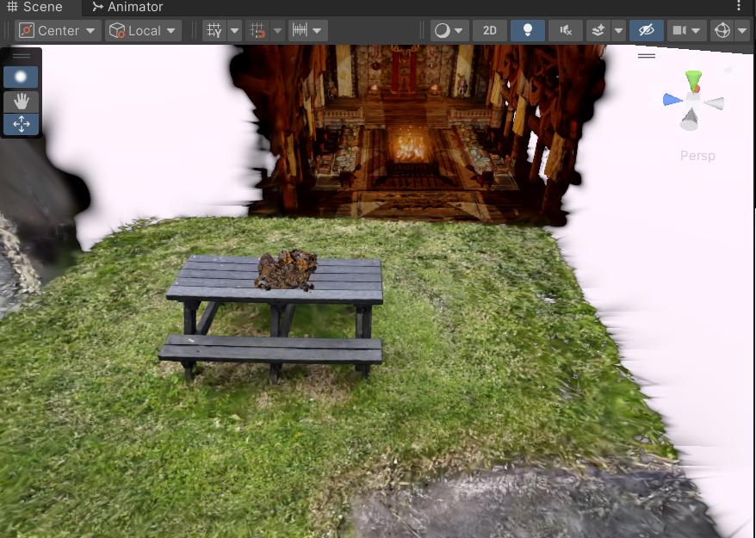

Figure 1: Unity Project Imported Gaussian Splat

The splats can be edited in a few ways, such as Individual Splats can be selected (Figure 2), they can then be moved (Figure 3) and can also be deleted (Figure 4).

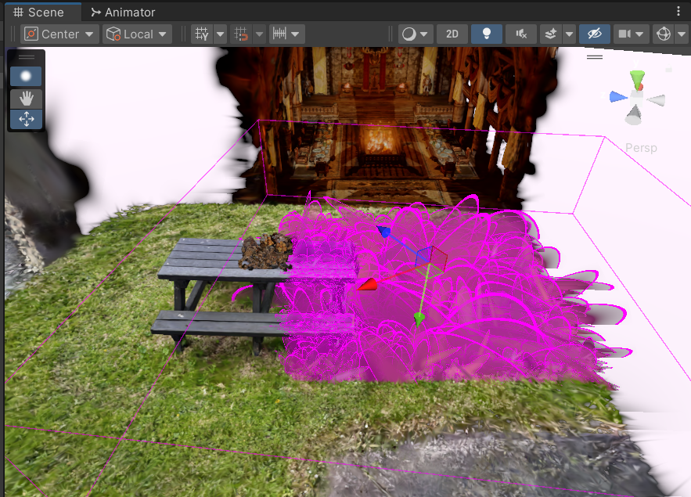

Figure 2: Unity Splat Selection

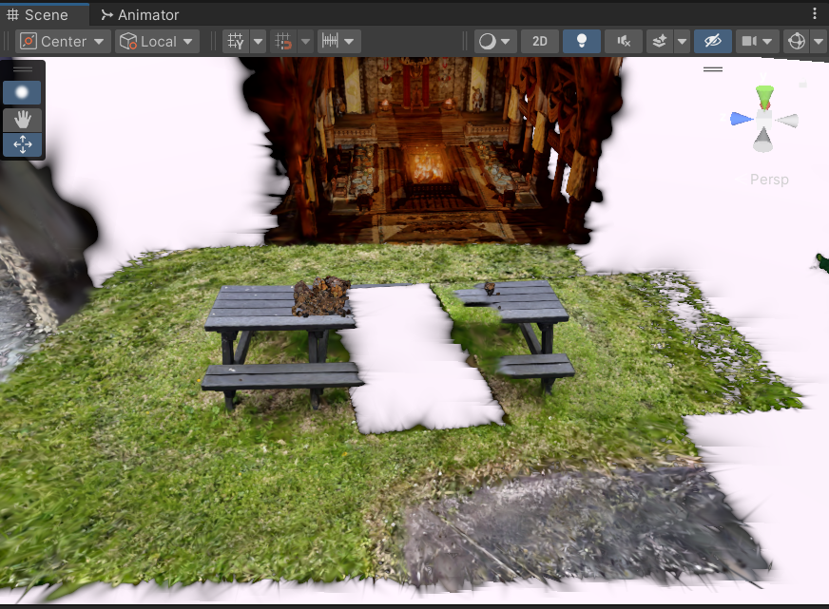

Figure 3: Unity Splat Movement

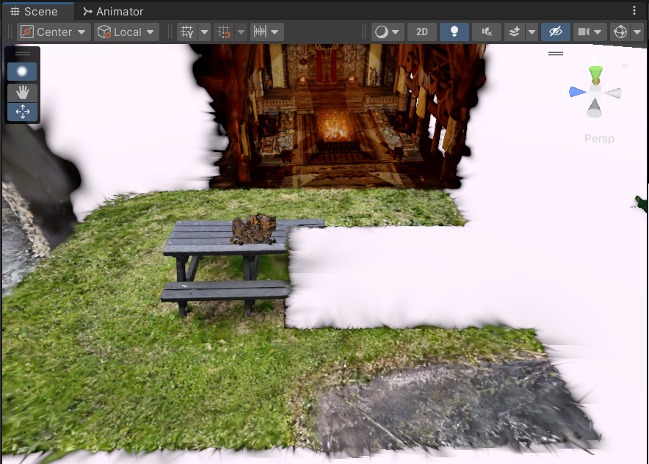

Figure 4: Unity Splat Deletion

Global attributes can also be altered such as scale (Figure 5) and opacity (Figure 6).

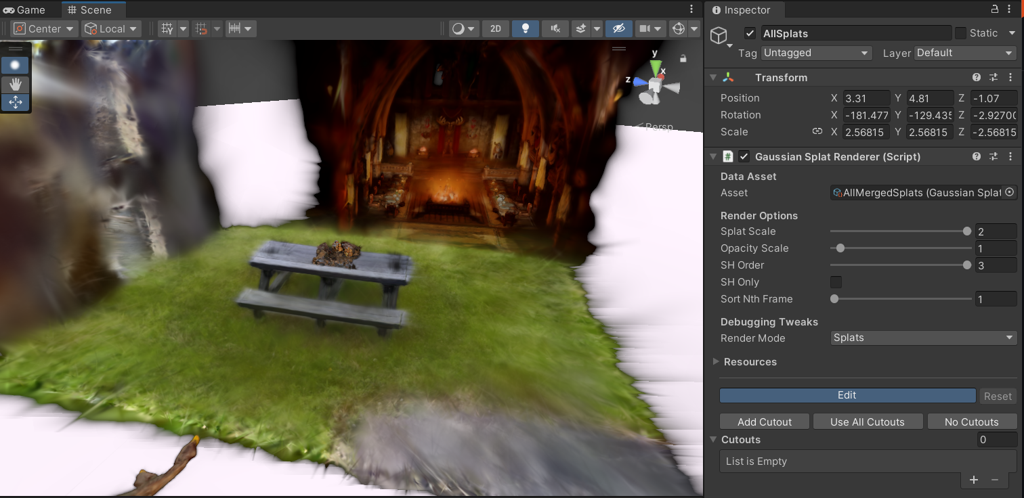

Figure 5: Unity Double Global Splat Scale

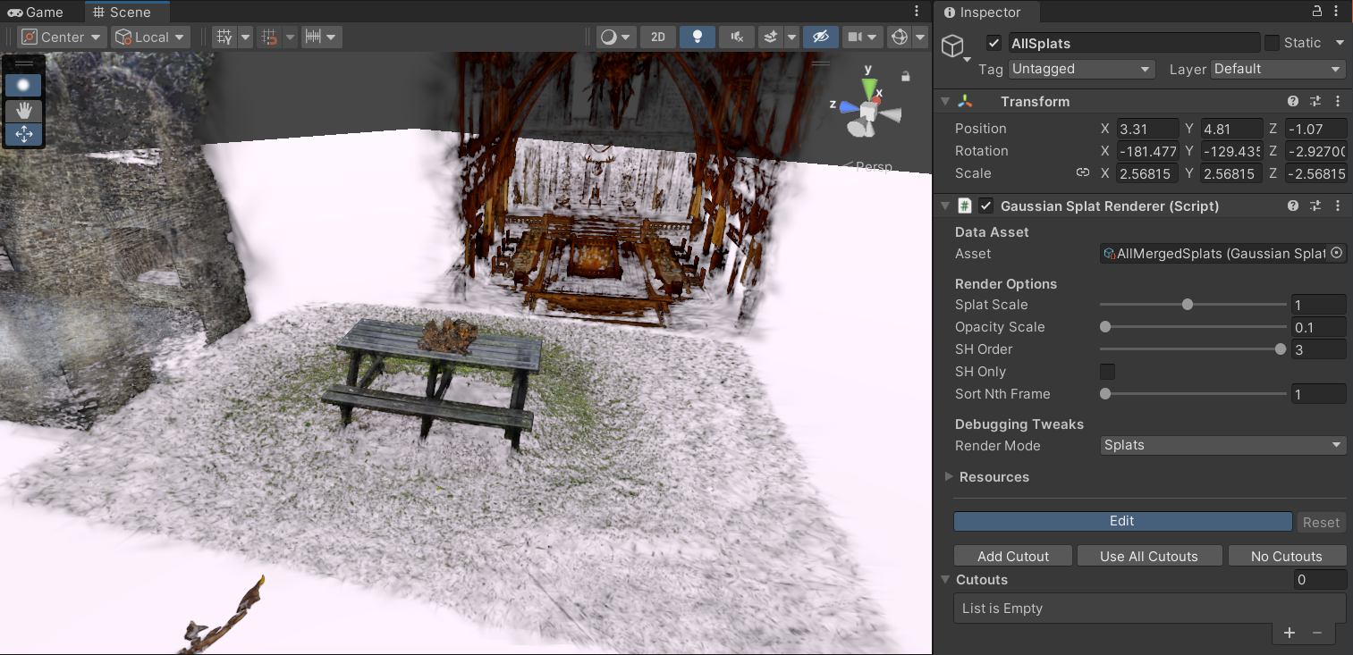

Figure 6: Unity 0.1 Splat Opacity

Multiple Splats can also be merged and exported as one Gaussian Splat, which is very useful for ensuring correct occlusion and creating novel scenes as demonstrated in the prototype (Prototype Image Reference).

### Editing the Project

#### Assessing the code:

The Unity project heavily relies on some complex C# script interactions and HLSL .shader language scripts to provide the rendering and editing of Gaussian Splats within Unity. To extend the functionality of the project a fundamental understanding of shader languages and Unity’s various scripting systems will be required. Vertex and Fragment Shader information can be found in the [Unity Shader Docs](https://docs.unity3d.com/6000.0/Documentation/Manual/writing-shader-programs-introduction.html) (Unity.com, 2025b). The Unity Editor API information can be referenced at [Unity Editor Docs](https://docs.unity3d.com/6000.0/Documentation/ScriptReference/Editor.html) (Unity.com, 2025c), with a tutorial at [Unity Editor Tutorial](https://learn.unity.com/tutorial/editor-scripting) (Unity.com, 2025a).

Editing the code:

Upon trying to open the project using Visual Studio the following error occurred:

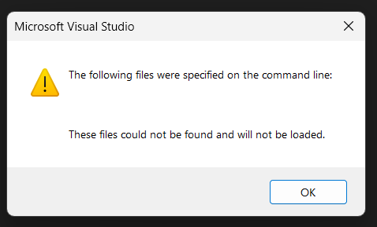

*Figure 7: Unity Project Visual Studio Error*

The error displayed in (Figure 7) was recreated across various hardware, two laptops and two desktop PCs running Windows 11 on both Nvidia and AMD hardware. A legacy 2017 version of Visual Studio was also tested with the same error occurring.

As such Visual Studio is unsuitable for editing the scripts and [JetBrains Rider](https://www.jetbrains.com/rider/) (JetBrains.com, 2025) was used instead.

After investigating the shader script with my supervisor, it was noted that the shader openly affects the rendered Splats. For instance, in the RenderGaussianSplats.shader (Figure 8) script, the selection colour can be changed by altering the RGB value.

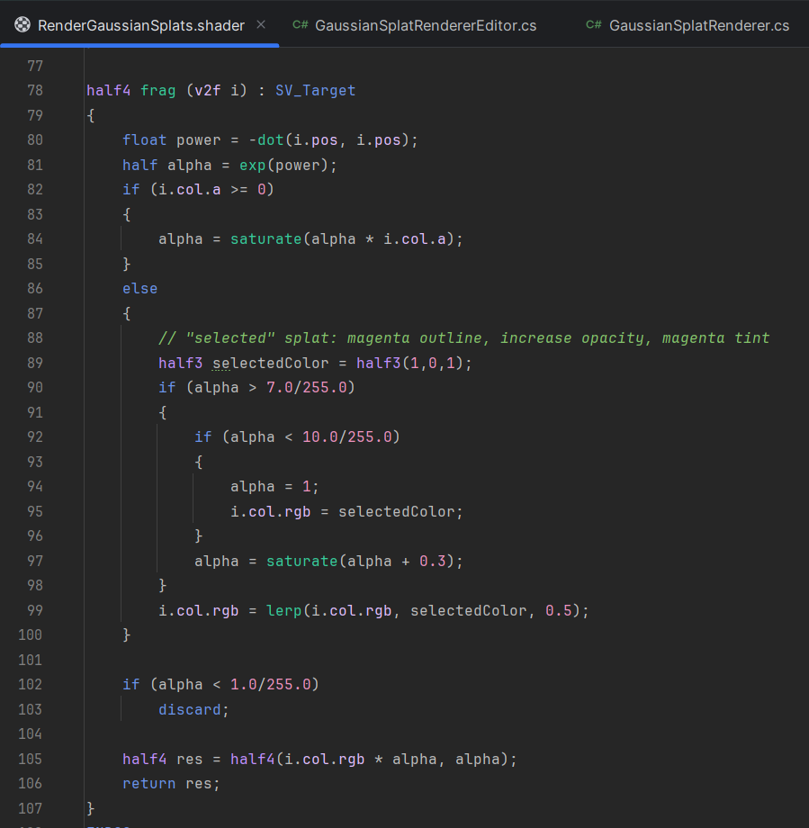

Figure 8: RenderGaussianSplats.shader Script Segment

Altering the selectedColor variable:





Figure 9: selectedColor Variable Code Alteration

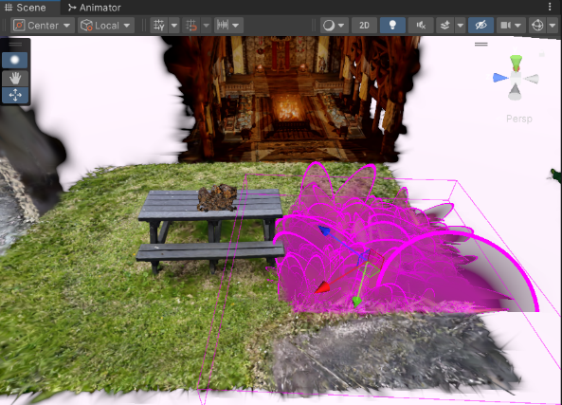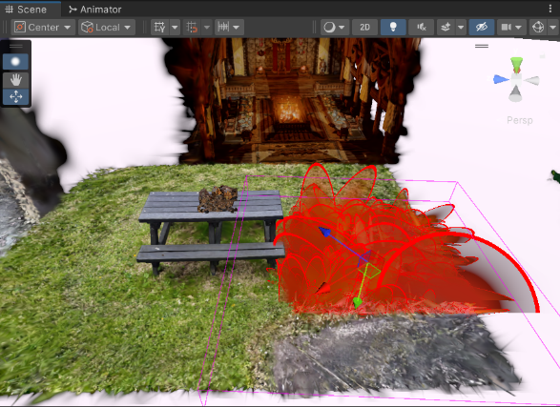

Figure 10: selectedColor Variable Code Alteration Result

Similarly, editing the RGBA values in the RenderGaussianSplats.shader script allows the alteration of the Splats globally:

For instance, multiplying the r part of the colour profile has the expected result of increasing the red tint of the scene.  
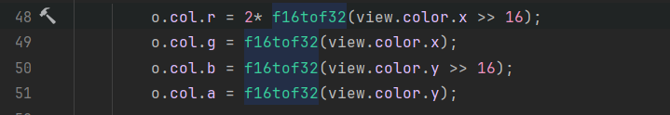

Figure 11: Altering Splat Colour Variables

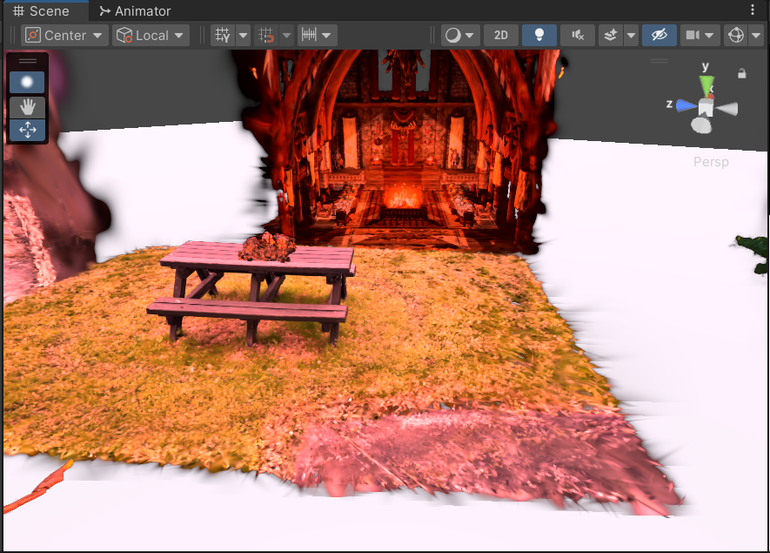

Figure 12: Altered Colour Profile

These initial alterations to the shader script showed the possibility of extending the functionality of the Unity project to allow individual and global colour alterations as desired. The main roadblocks at this time were adding this functionality into the existing Unity inspector UI and saving the changes permanently. An investigation into the code behind the current inspector UI (Figure 13) and expanding it was the next step.

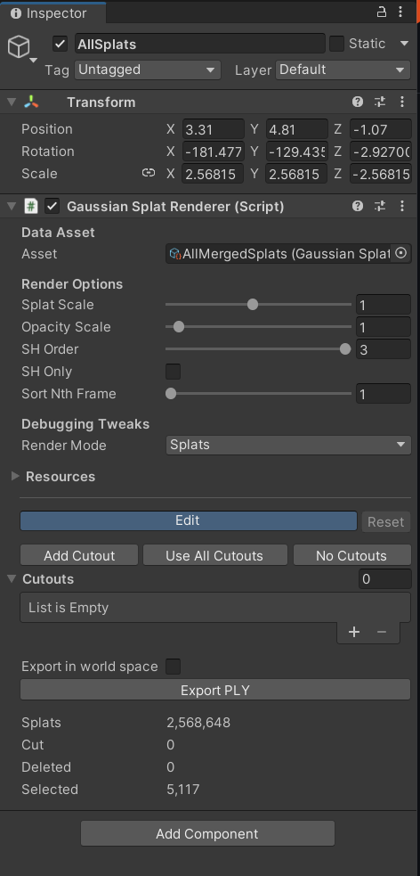

Figure 13: Original Unity Splat Inspector UI

The Inspector UI is dictated by the GaussianSplatRendererEditor.cs Script (Figure 14). Each serializedObject corresponds to a field in the Inspector.

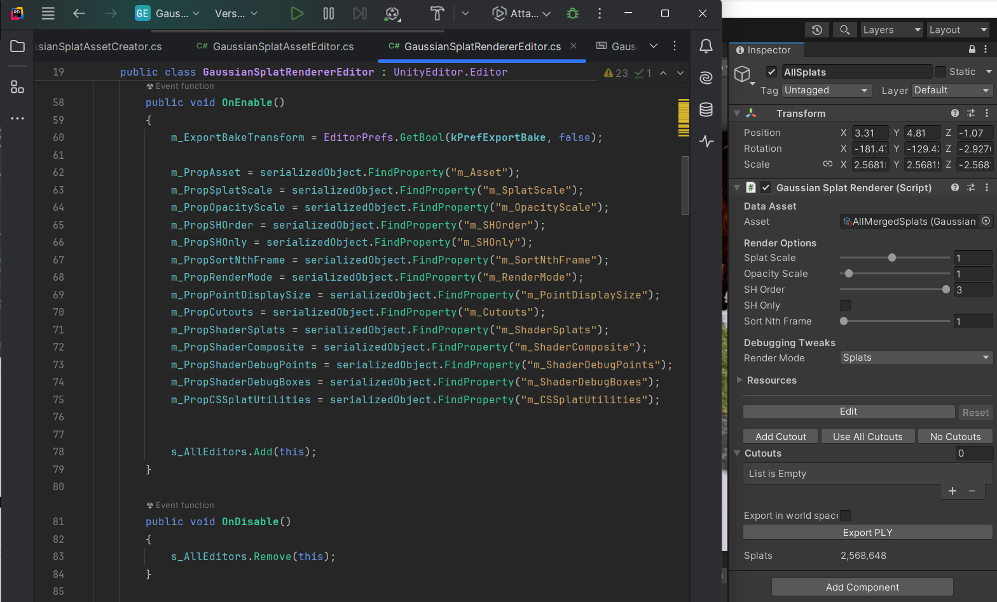

Figure 14: Unity Splat Editor Script Variables

This script logic can be edited and added to expand the Inspector UI, the additions in the GaussianSplatRendererEditor.cs script must be followed into the GaussianSplatRenderer Script as the editor script has references to the underlying renderer script. Once these changes are made correctly the updated fields are present in the inspector as seen in (Figure 15).

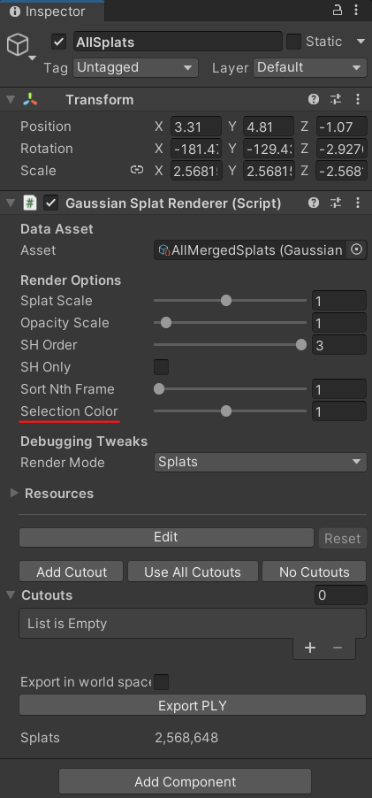

Figure 15: Unity Inspector Selection Colour Addition

The Selection Colour is currently set to alter the Splat Opacity as can be seen in the code snippet (Figure 16) affecting the Splats when altered in the inspector (Figure 17).

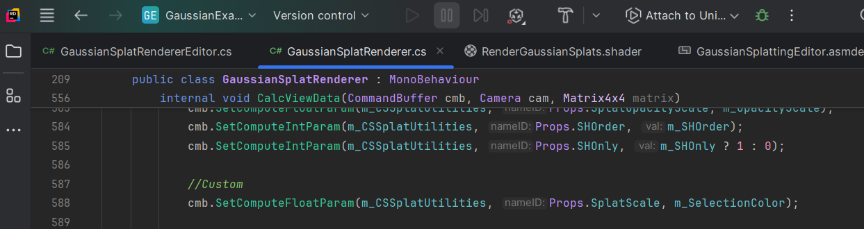

Figure 16: SelectionColor Variable

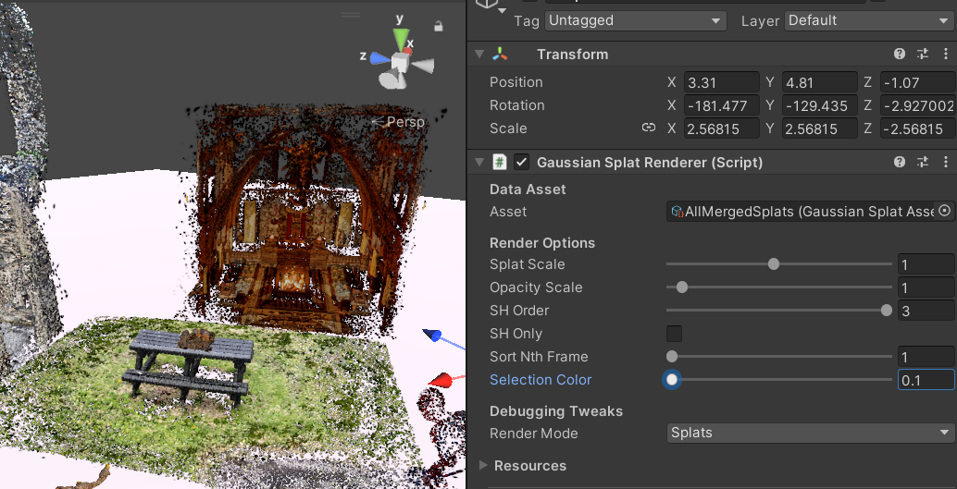

Figure 17: Selection Color Inspector

### Sprint Retrospective

With the addition to the Unity inspector UI the sprint came to an end. Understanding the current functionality of this Unity project took longer than anticipated, as such not much progress was made on adding more functionality to the project. The additions made in this sprint were a good foundation for expanding the tools available. Adding the correct functionality for additonal Inspector tools will be a part of Sprint 2.

# References

JetBrains.com, 2025. *Rider: The Cross-Platform .NET IDE from JetBrains*. [online] JetBrains. Available at: <https://www.jetbrains.com/rider/> [Accessed 9 February 2025].

Pranckevičius, A., 2024. *Toy Gaussian Splatting visualization in Unity*. Available at: <https://github.com/aras-p/UnityGaussianSplatting> [Accessed 2 December 2024].

Snavely, N., Seitz, S.M. and Szeliski, R., 2006. Photo tourism: exploring photo collections in 3D. In: *ACM SIGGRAPH 2006 Papers*, SIGGRAPH ’06. [online] New York, NY, USA: Association for Computing Machinery. pp.835–846. https://doi.org/10.1145/1179352.1141964.

Unity.com, 2025a. *Editor Scripting Tutorial*. [online] Unity Learn. Available at: <https://learn.unity.com/tutorial/https:/learn.unity.com/tutorial/editor-scripting> [Accessed 9 February 2025].

Unity.com, 2025b. *Unity - Manual: Shader program fundamentals*. [online] Available at: <https://docs.unity3d.com/6000.0/Documentation/Manual/writing-shader-programs-introduction.html> [Accessed 9 February 2025].

Unity.com, 2025c. *Unity - Scripting API: Editor*. [online] Available at: <https://docs.unity3d.com/6000.0/Documentation/ScriptReference/Editor.html> [Accessed 9 February 2025].